Brain Tumor Classification Using AlexNet-Based Deep Convolutional Neural Network and MRI Image Analysis

Prachi Anand
School of Computer Science and Engineering
Shri Mata Vaishno Devi University
Jammu, India
23bcs064@smvdu.ac.in

Abstract—Brain tumors are one of the most dangerous neurological disorders affecting millions of people worldwide. Early and accurate diagnosis of brain tumors is extremely important because delayed detection may lead to severe health complications and reduced survival rates. Magnetic Resonance Imaging (MRI) is widely used for detecting abnormalities in brain tissues because it provides detailed and high-resolution images without harmful radiation exposure. However, manual analysis of MRI images by radiologists is time-consuming and may sometimes result in inaccurate diagnosis due to image complexity and similarities among tumor structures.
Recent advancements in Artificial Intelligence and Deep Learning have significantly improved medical image analysis systems. Convolutional Neural Networks (CNNs) are among the most effective deep learning models for image classification tasks because they can automatically learn meaningful image features from raw image data. In this research work, an AlexNet-based Deep Convolutional Neural Network is implemented using PyTorch for multiclass brain tumor classification.
The dataset used in this work contains MRI brain images belonging to four categories: glioma tumor, meningioma tumor, pituitary tumor, and no tumor. The dataset is divided into training, validation, and testing subsets using a stratified splitting technique with proportions of 70%, 15%, and 15% respectively. Several preprocessing and augmentation techniques such as image resizing, normalization, horizontal flipping, random rotation, and cropping are applied to improve model generalization and reduce overfitting.
The AlexNet model is trained using GPU acceleration in Google Colab. The performance of the model is evaluated using different performance metrics including accuracy, precision, recall, F1-score, confusion matrix, and ROC-AUC analysis. Experimental results demonstrate that the proposed CNN-based AlexNet architecture achieves reliable and efficient performance for automated brain tumor classification tasks.)
Keywords—Brain Tumor Classification, Deep Learning, AlexNet, MRI Images, Convolutional Neural Network, PyTorch, Medical Image Analysis.

Introduction

Brain tumors are abnormal growths of cells inside the brain that can severely affect the normal functioning of the nervous system. Early and accurate diagnosis of brain tumors is essential for effective treatment and patient survival. Magnetic Resonance Imaging (MRI) is widely used for brain tumor detection because it provides detailed images of brain tissues and abnormalities.

Traditional methods of brain tumor diagnosis mainly depend on manual analysis by radiologists, which can be time-consuming and prone to errors. Recent advancements in Artificial Intelligence and Deep Learning have significantly improved medical image analysis systems. Convolutional Neural Networks (CNNs) are highly effective for image classification tasks because they automatically extract important features from images.

In this work, an AlexNet-based CNN model is implemented using PyTorch for multiclass brain tumor classification. The MRI dataset is categorized into four classes: glioma tumor, meningioma tumor, pituitary tumor, and no tumor. The proposed model is trained and evaluated using multiple performance metrics including accuracy, precision, recall, F1-score, confusion matrix, and ROC-AUC analysis.

RELATED WORK
Several machine learning and deep learning techniques have been proposed for brain tumor classification using MRI images. Traditional methods such as SVM and KNN required manual feature extraction and achieved limited accuracy.
Recent deep learning models, especially Convolutional Neural Networks (CNNs), have shown better performance in medical image classification tasks. AlexNet introduced deep CNN architecture with improved feature extraction and classification capability. Other architectures such as ResNet and VGG16 have also been used for brain tumor detection. In this work, AlexNet is used because of its efficient performance and simpler architecture.

METHODOLOGY

Dataset Description

The dataset used in this work contains MRI brain images belonging to four classes:
• Glioma Tumor
• Meningioma Tumor
• Pituitary Tumor
• No Tumor

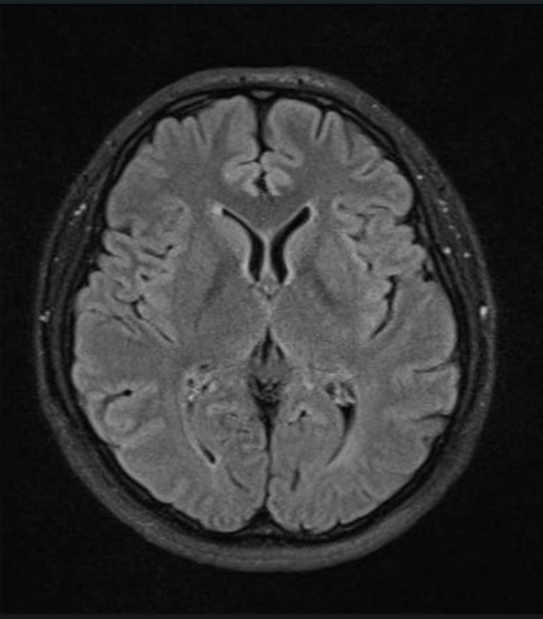
Fig. 1 shows sample MRI brain images from different tumor classes used in the dataset. The dataset contains MRI scans of glioma tumor, meningioma tumor, pituitary tumor, and no tumor categories.

No Tumor

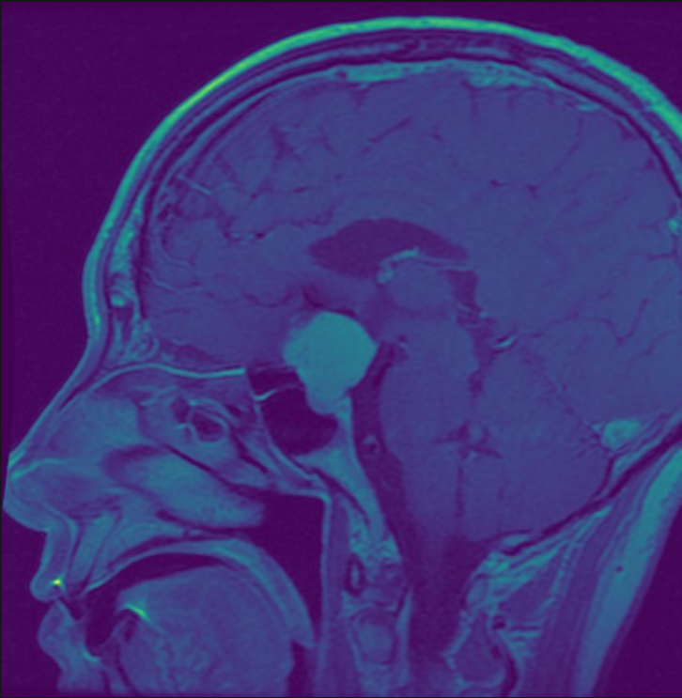

Meningioma

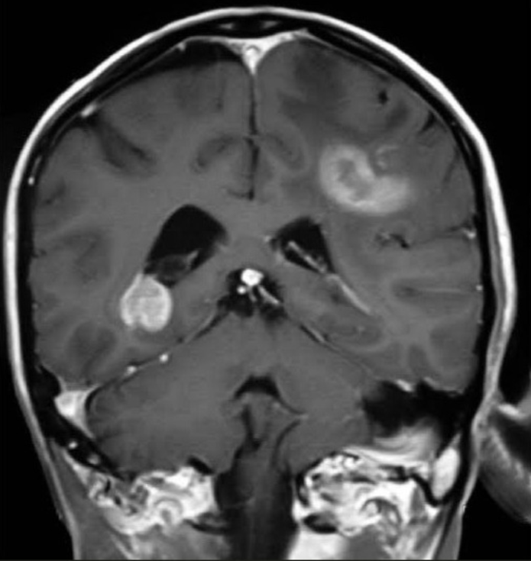

Glioma

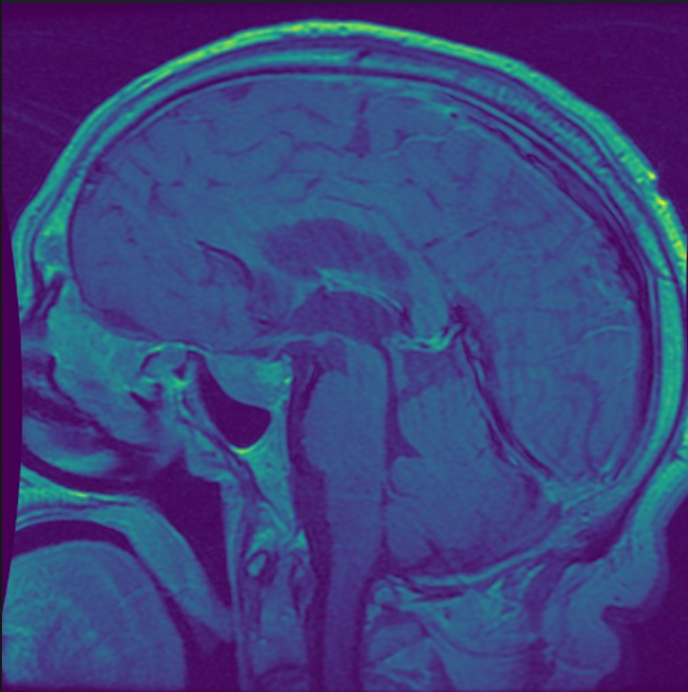
Pituitary

The images are stored in separate folders according to their class labels and are available in JPG and PNG formats.

B. Dataset Splitting

The dataset was divided using stratified splitting:
• 70% Training Data
• 15% Validation Data
• 15% Testing Data

C. Data Preprocessing

All MRI images were resized to 224 × 224 pixels and normalized before training. Data augmentation techniques such as random rotation and horizontal flipping were applied to improve model generalization and reduce overfitting.

D. AlexNet Architecture

AlexNet consists of convolutional layers, pooling layers, ReLU activation functions, dropout layers, and fully connected layers. The architecture extracts important image features and performs multiclass classification.

E. Model Training

The model was implemented using PyTorch and trained using GPU acceleration in Google Colab. The Adam optimizer and CrossEntropyLoss function were used during training.

EXPERIMENTS AND RESULTS

Accuracy
The training and validation curves demonstrate that the AlexNet model learned effectively during the training process. The accuracy increased steadily with epochs while the loss decreased continuously, indicating proper convergence and reduced prediction error.

EXPERIMENTS AND RESULTS

The performance of the AlexNet model was evaluated using different performance metrics including accuracy, precision, recall, F1-score, confusion matrix, and ROC-AUC analysis.

A. Accuracy
The model achieved high classification accuracy across all tumor categories, demonstrating effective feature extraction and reliable prediction capability.

:contentReference[oaicite:0]{index=0}

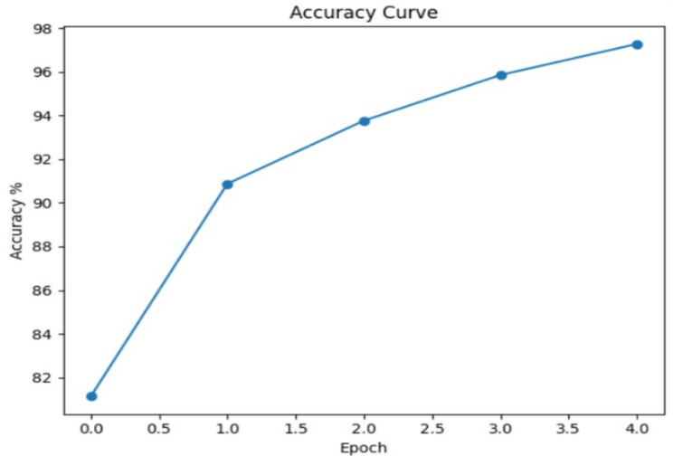

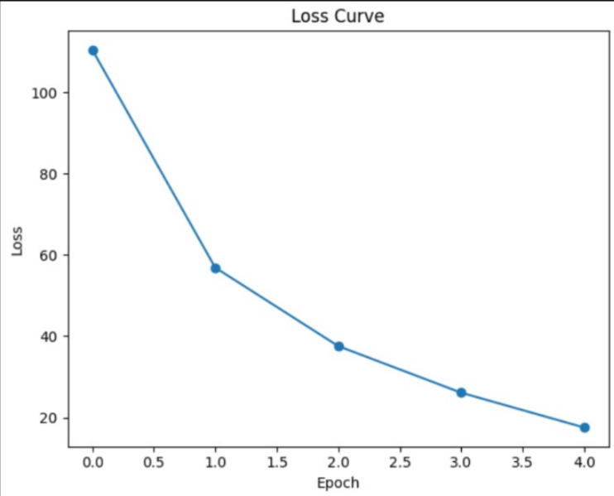

Fig. 2. Training Accuracy and Loss Curve of AlexNet Model

B. Precision

Precision measures the proportion of correctly predicted positive observations among all predicted positive observations.

:contentReference[oaicite:1]{index=1}

C. Recall
Recall measures the ability of the model to correctly identify actual tumor samples.

:contentReference[oaicite:2]{index=2}

D. F1-Score
F1-score provides a balanced evaluation between precision and recall.

:contentReference[oaicite:3]{index=3}

E. ROC-AUC Curve

The ROC-AUC curve demonstrates strong classification capability across all tumor classes. High AUC values indicate that the model effectively distinguishes between tumor and non-tumor MRI images under different threshold conditions.

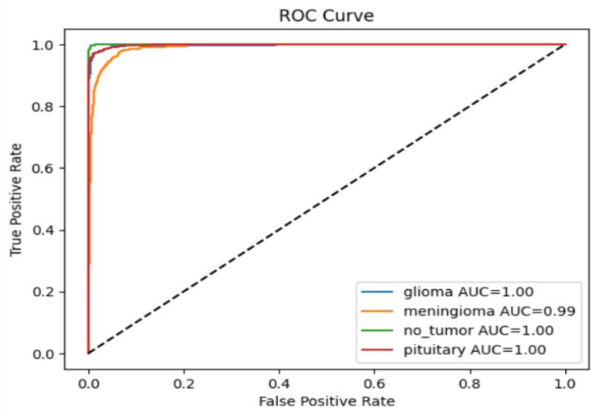

DISCUSSION
The experimental results demonstrate that the AlexNet architecture performs effectively for multiclass brain tumor classification tasks. The CNN model successfully extracted meaningful image features and achieved reliable classification performance across different tumor categories.
Data preprocessing and augmentation techniques improved model generalization and reduced overfitting. Although advanced architectures such as ResNet and DenseNet may achieve higher accuracy, AlexNet remains computationally efficient and easier to implement for educational and research purposes.

CONCLUSION AND FUTURE WORK
In this work, an AlexNet-based Deep Convolutional Neural Network was implemented using PyTorch for brain tumor classification using MRI images. The dataset was divided into training, validation, and testing subsets using a stratified approach. Experimental results demonstrated reliable classification performance across multiple evaluation metrics.
Future work may include larger MRI datasets, transfer learning approaches, real-time deployment, and comparison with advanced CNN architectures.
ACKNOWLEDGMENT
The authors would like to thank the Department of Computer Science and Engineering, Shri Mata Vaishno Devi University, for providing guidance and support during the completion of this project.
REFERENCES
[1] A. Krizhevsky, I. Sutskever, and G. E. Hinton, “ImageNet Classification with Deep Convolutional Neural Networks,” Advances in Neural Information Processing Systems, 2012.
[2] Y. LeCun, Y. Bengio, and G. Hinton, “Deep Learning,” Nature, vol. 521, pp. 436–444, 2015.
[3] K. He, X. Zhang, S. Ren, and J. Sun, “Deep Residual Learning for Image Recognition,” CVPR, 2016.
[4] D. P. Kingma and J. Ba, “Adam: A Method for Stochastic Optimization,” arXiv preprint arXiv:1412.6980, 2014.
[5] O. Russakovsky et al., “ImageNet Large Scale Visual Recognition Challenge,” IJCV, 2015.
[6] I. Goodfellow, Y. Bengio, and A. Courville, Deep Learning, MIT Press, 2016.
[7] J. Deng et al., “ImageNet: A Large-Scale Hierarchical Image Database,” CVPR, 2009.
[8] S. Albawi, T. A. Mohammed, and S. Al-Zawi, “Understanding of a Convolutional Neural Network,” International Conference on Engineering and Technology, 2017.
[9] K. Simonyan and A. Zisserman, “Very Deep Convolutional Networks for Large-Scale Image Recognition,” ICLR, 2015.
[10] M. Tan and Q. Le, “EfficientNet: Rethinking Model Scaling for Convolutional Neural Networks,” ICML, 2019.

